User can’t be registered directly as admin. Admin is added manually through database after a person is registered a user. Admin can perform all activites that a normal user can perform so chek user guidelines. Some features that only Admin can perform is guided below.

Admin can add API and the API key for those API is generated automatically by system.

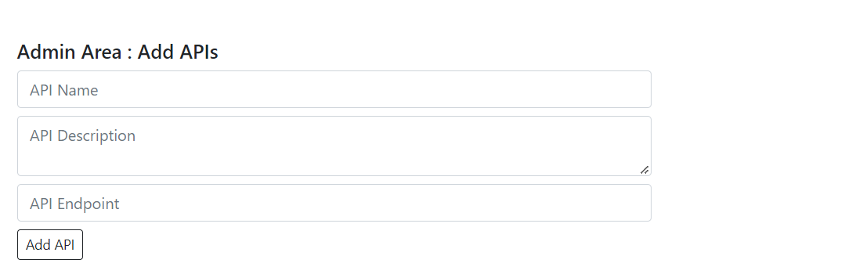

Admin can see how many times a API has been called .

